**EXPERIMENT-11**

**AIM:** prompt (message, default)

**CODE:**

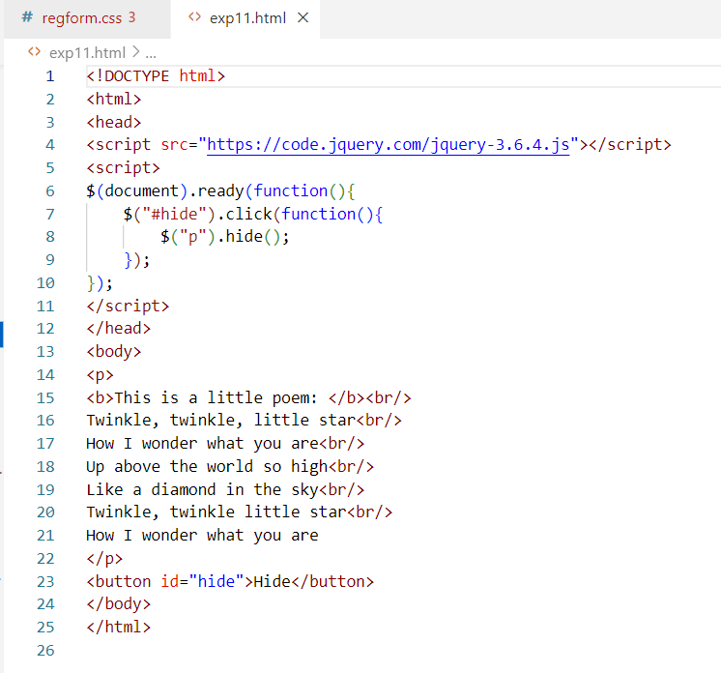

**OUTPUT:**

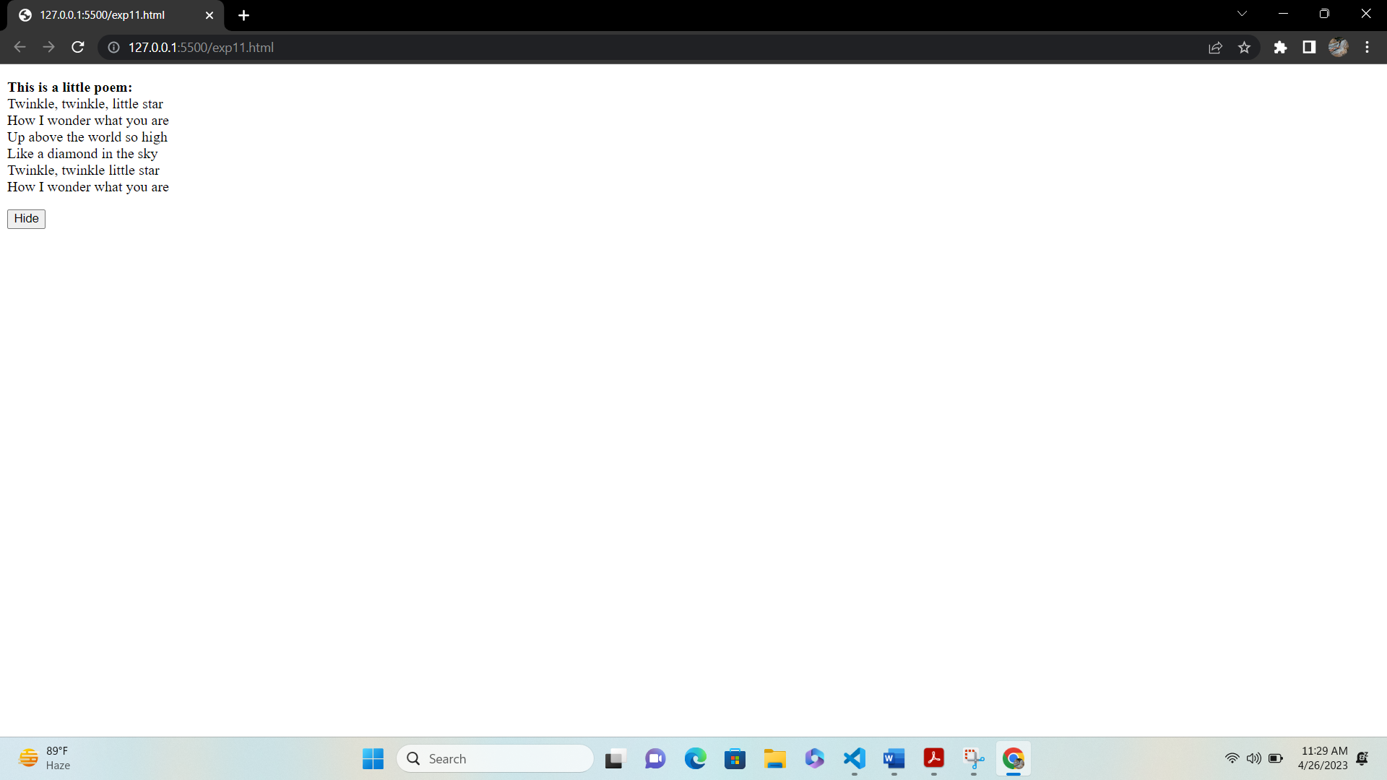

**EXPERIMENT-12**

**AIM:** Design HTML form for keeping student record and validate it using Java script.

**CODE:**

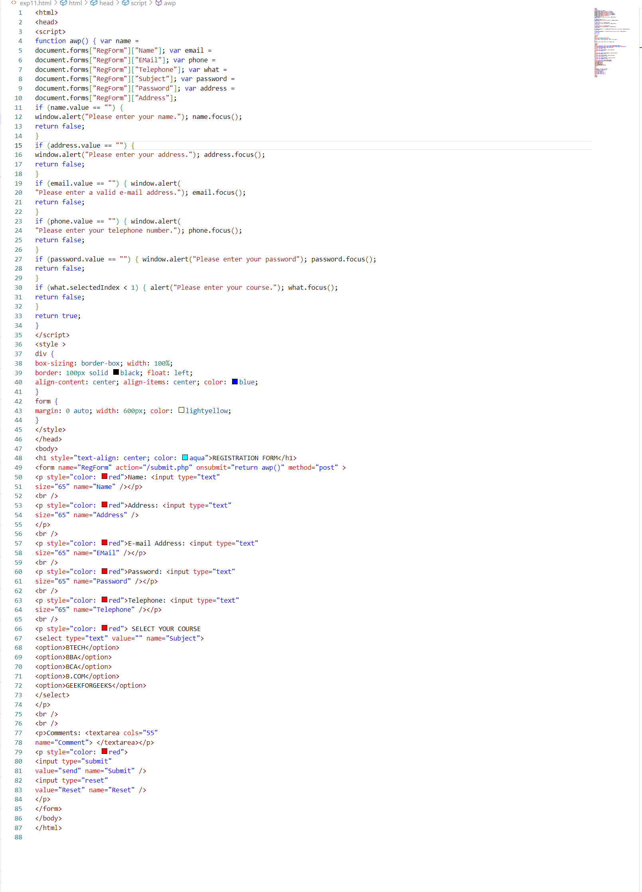

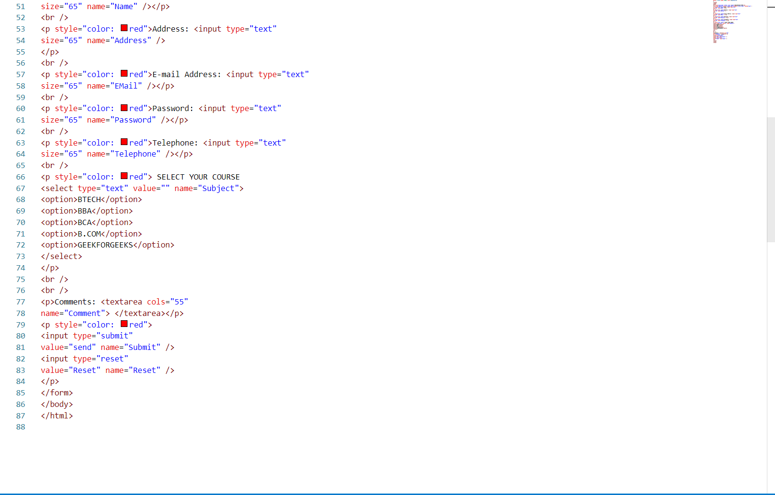

**OUTPUT:**

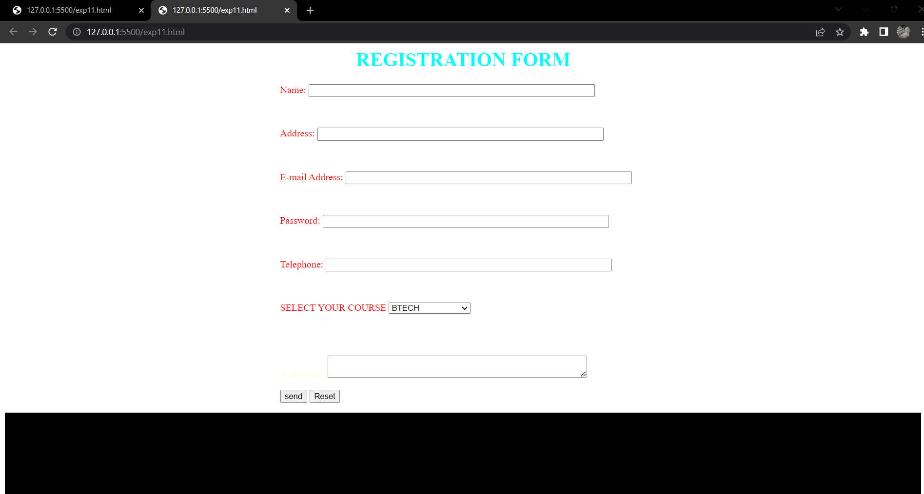

**EXPERIMENT-13**

**AIM:** Write programs using Java script for Web Page to display browsers information

**CODE:**

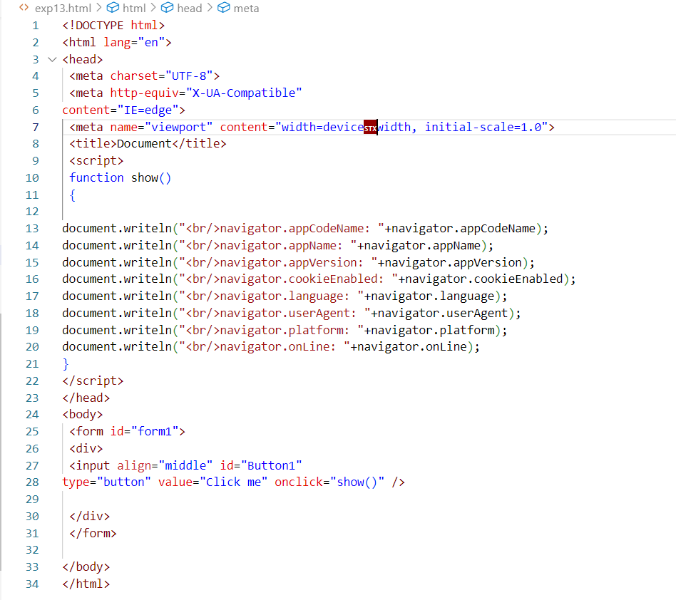

**OUTPUT:**

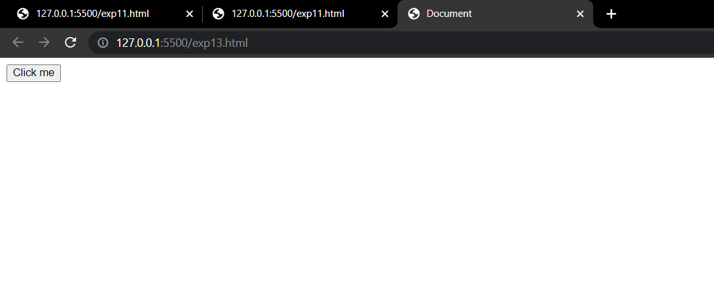

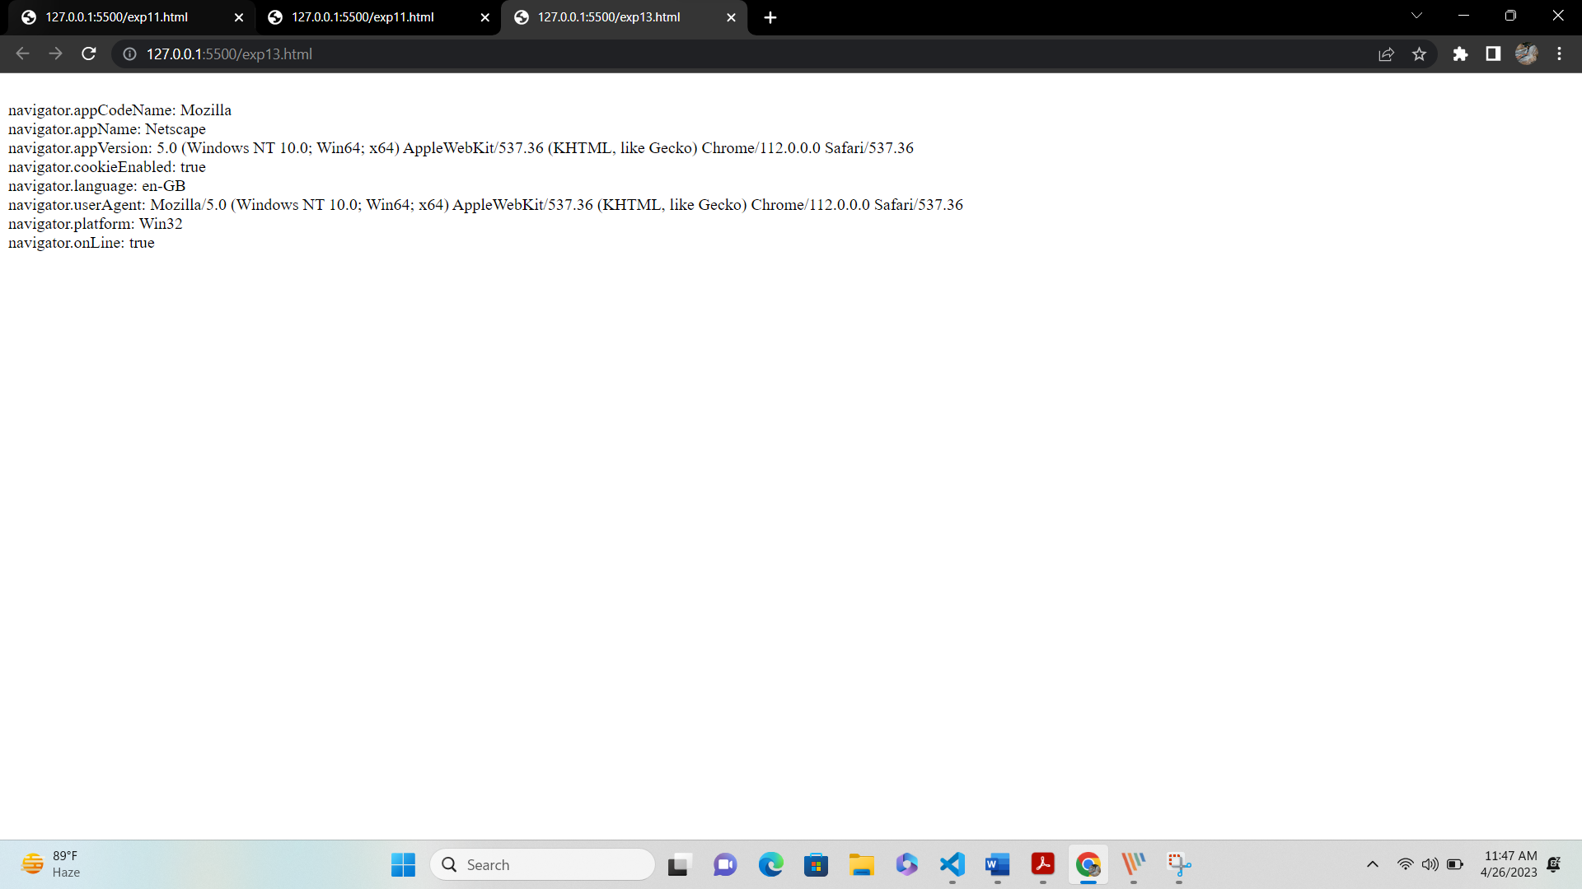

**EXPERIMENT-14**

**AIM:** Validate form page using JavaScript

**CODE:**

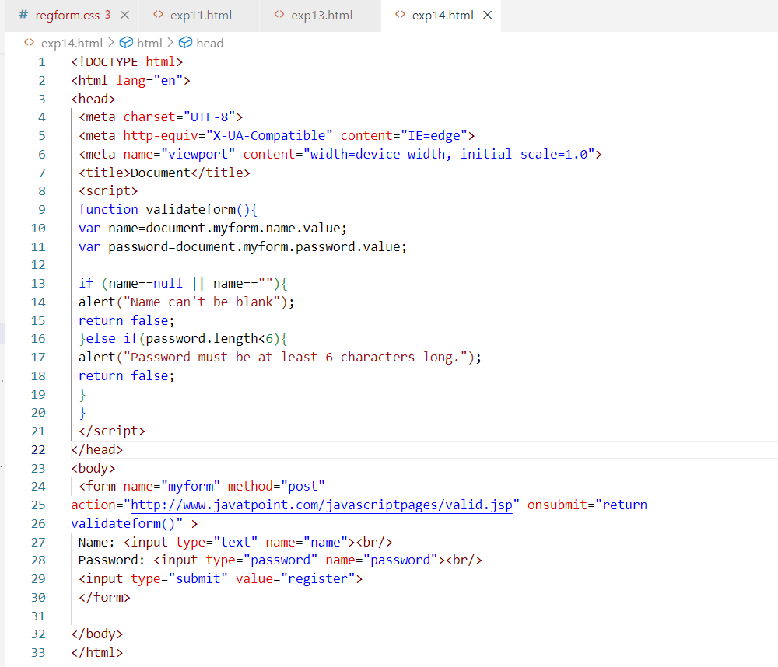

**OUTPUT:**

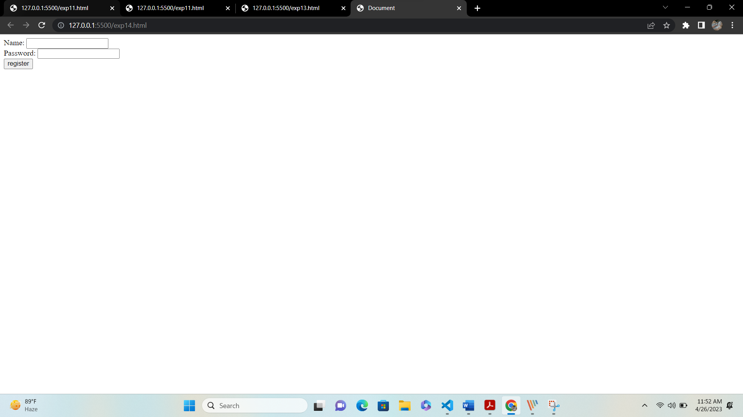

**EXPERIMENT-15**

**AIM:** Use JQuery hide() effect in page

**CODE:**

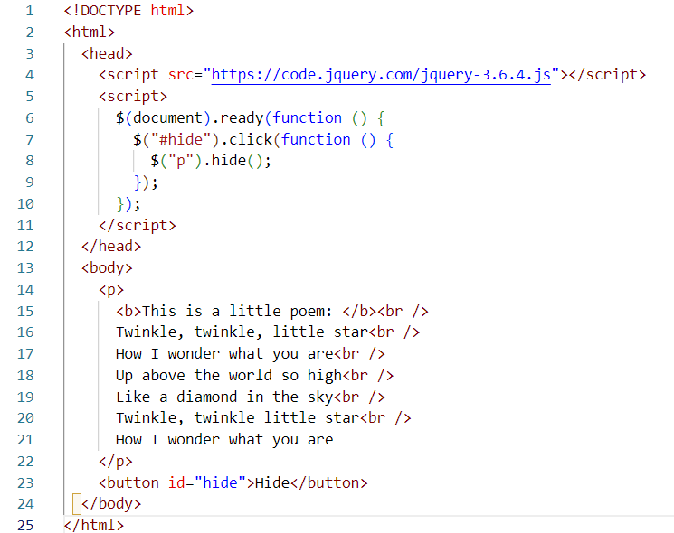

**OUTPUT:**

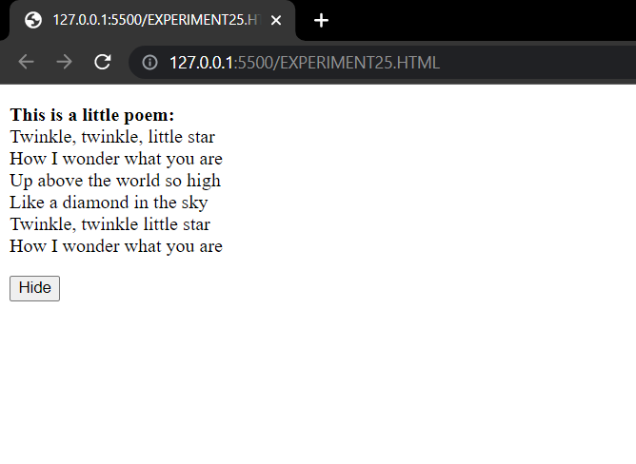

**EXPERIMENT-16**

**AIM:** Write a jQuery Code to Find the data passed with the on() method for each element

**CODE:**

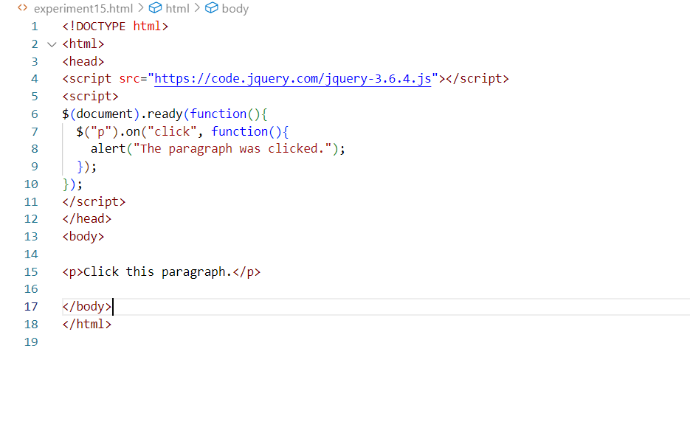

**OUTPUT:**

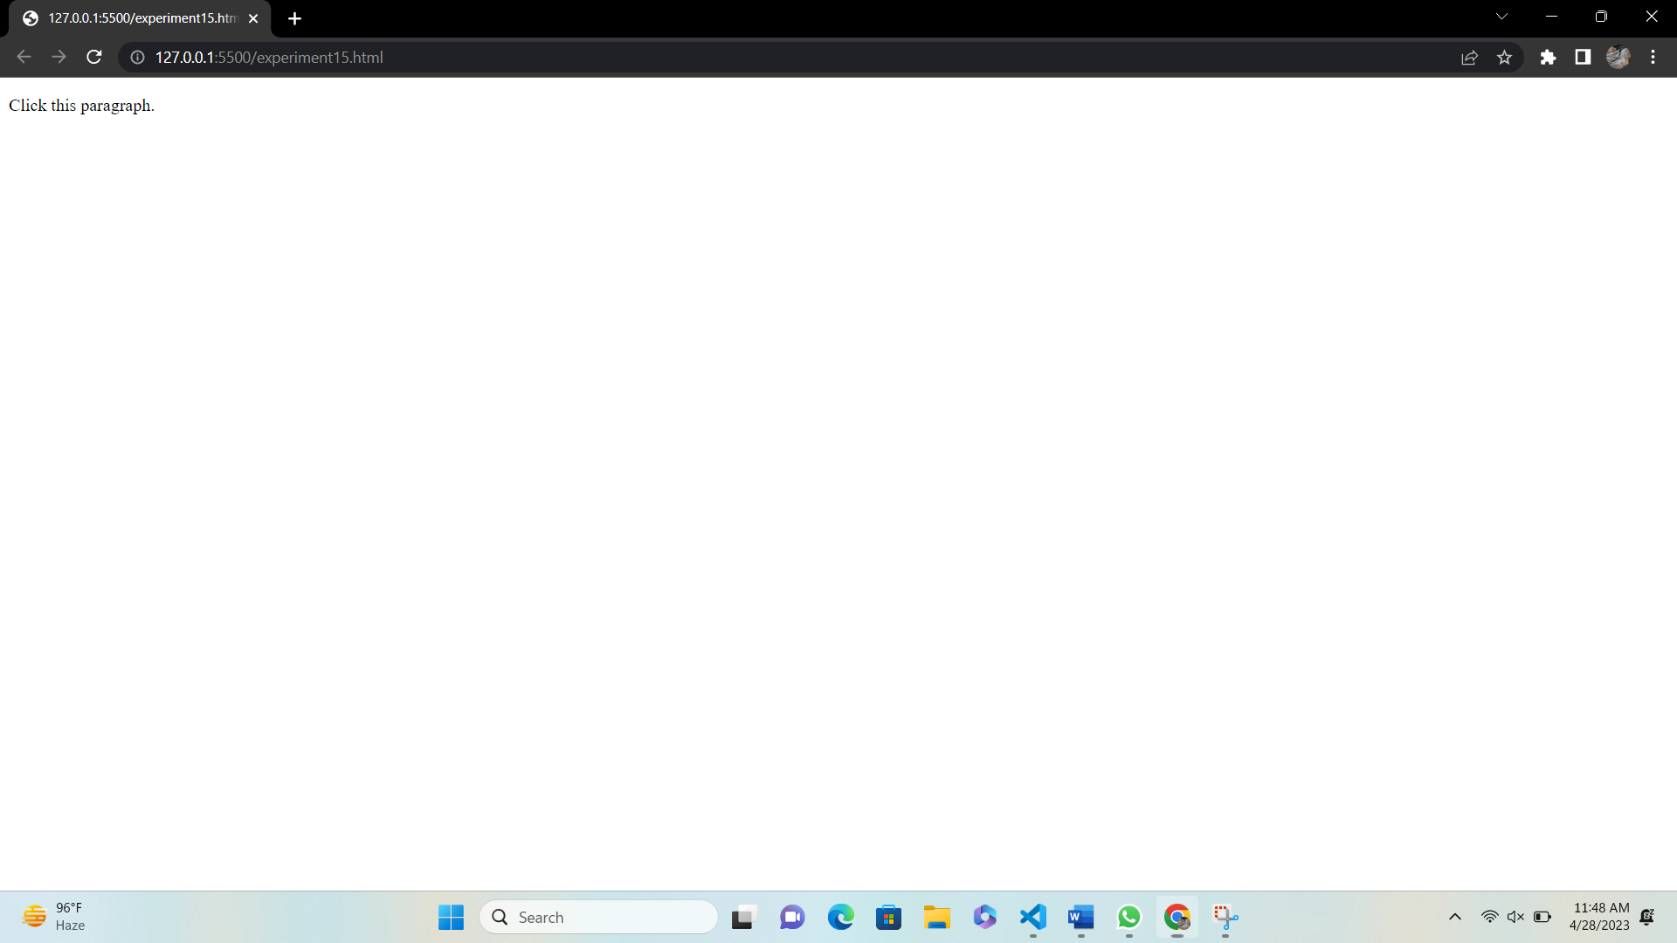

**EXPERIMENT-17**

**AIM:** Find the position of the mouse pointer relative to the left and top edges of the document.

**CODE:**

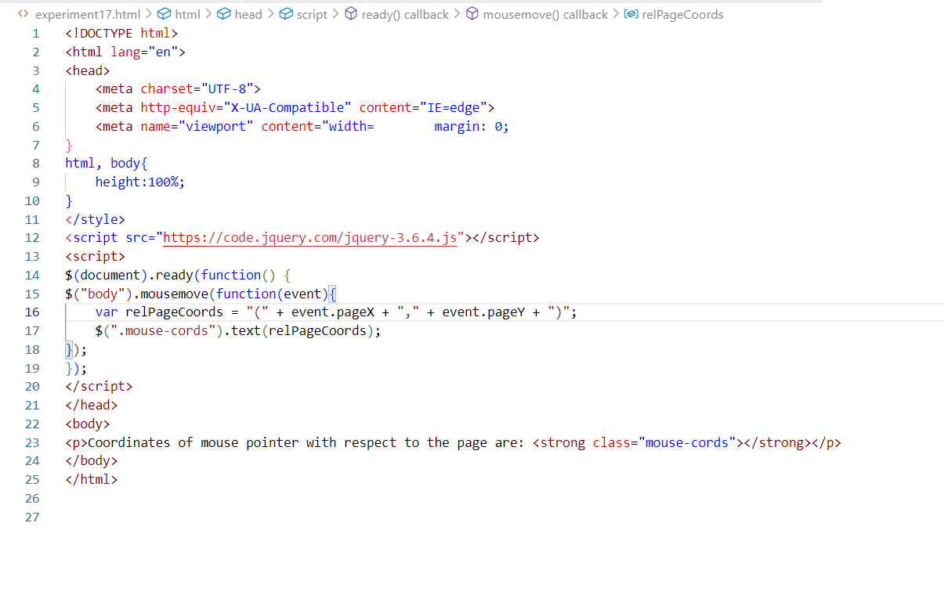

**OUTPUT:**

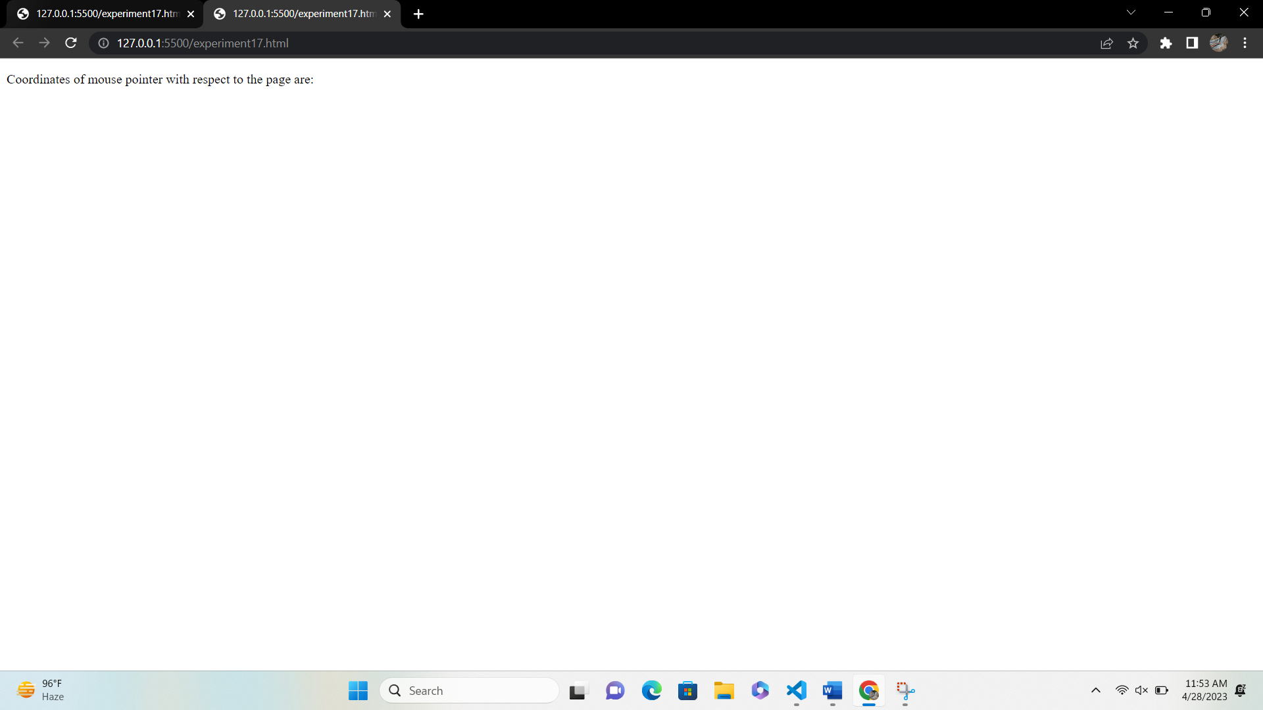

**EXPERIMENT-18**

**AIM:** Count the number of milliseconds between the two click events on a paragraph

**CODE:**

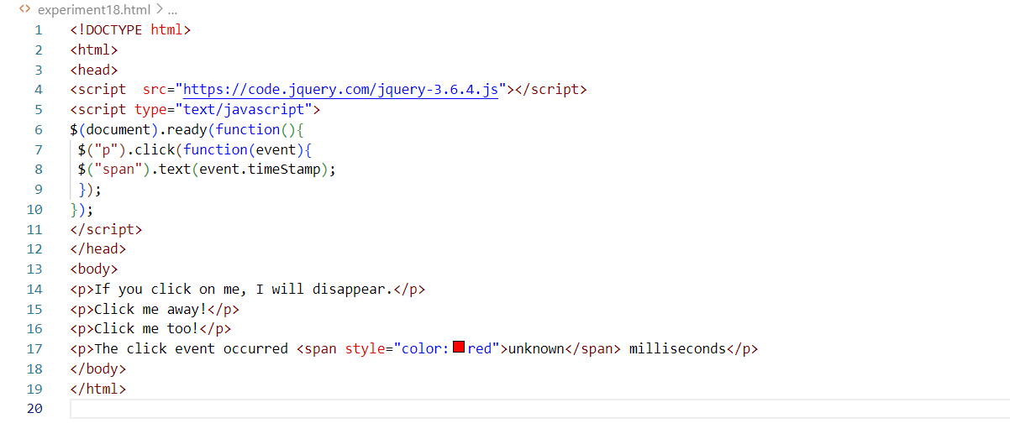

**OUTPUT:**

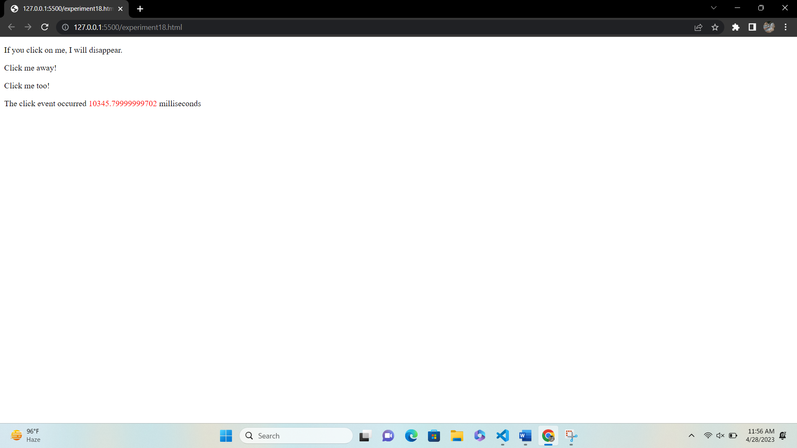

**EXPERIMENT-19**

**AIM:** Find all the text nodes inside a paragraph and wrap them with an italic tag.

**CODE:**

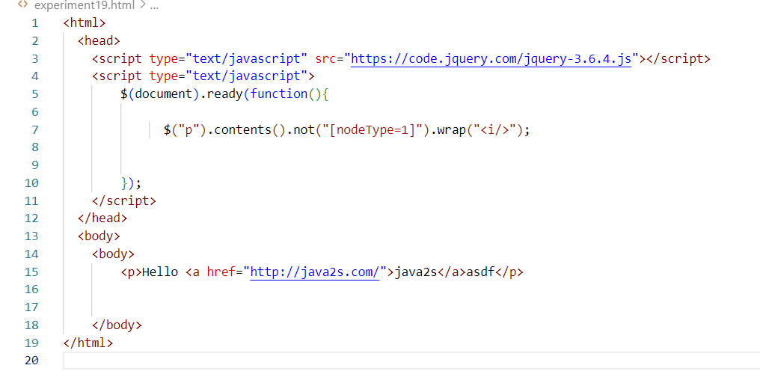

**OUTPUT:**

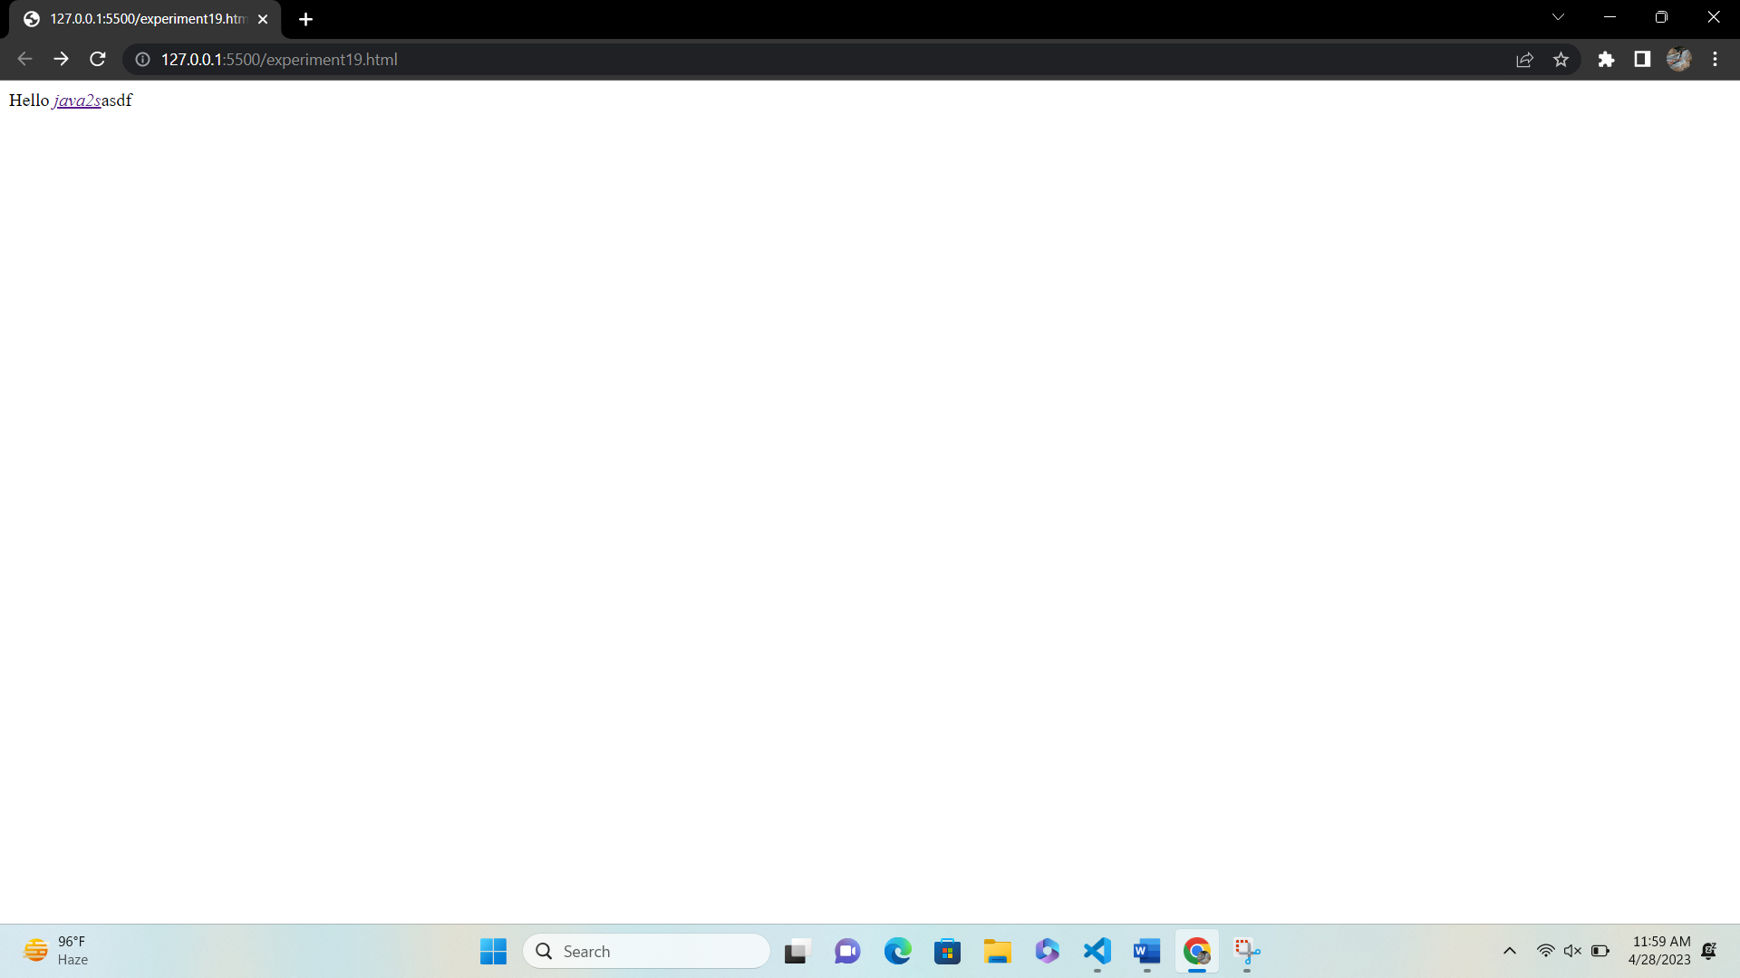

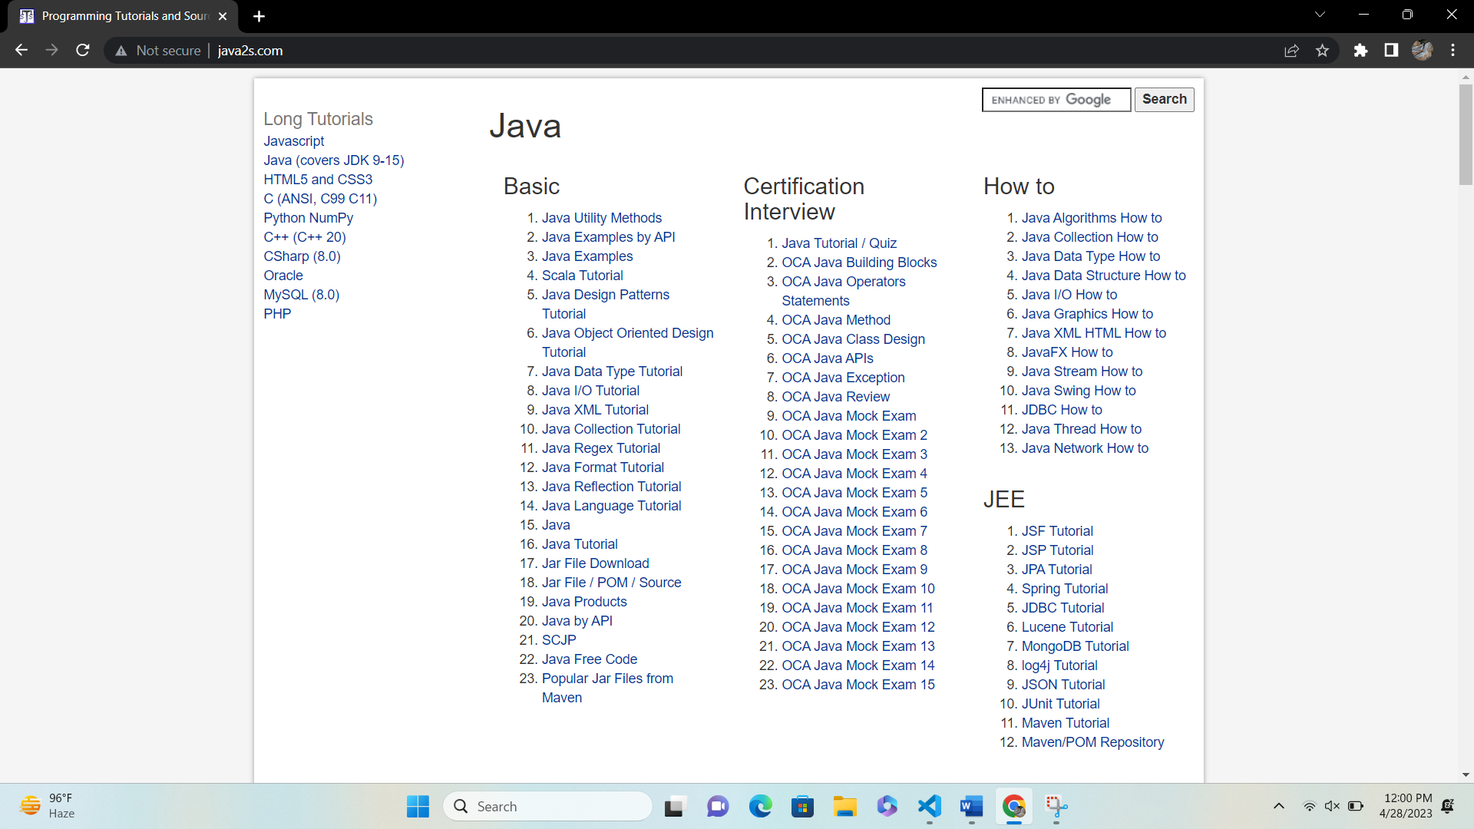

**EXPERIMENT-20**

**AIM:** Create an simple application using AJAX to show the table of numbers given by user at runtime

**CODE:**

**HTML CODE**

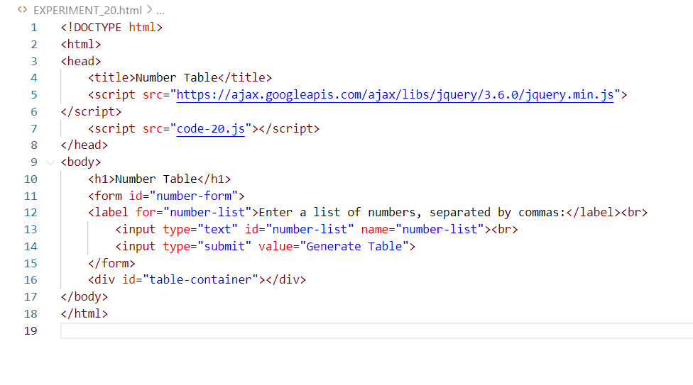

**JS CODE**

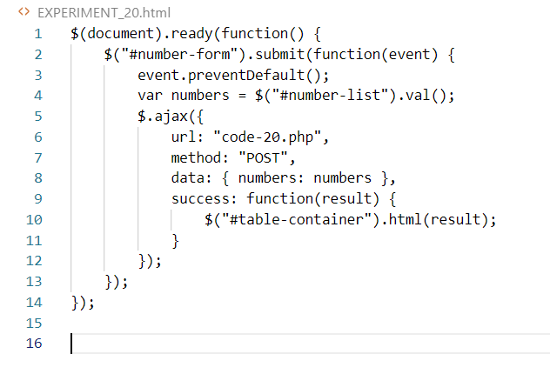

**PHP CODE:**

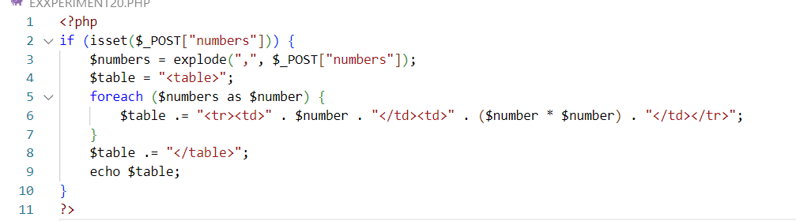

**OUTPUT:**

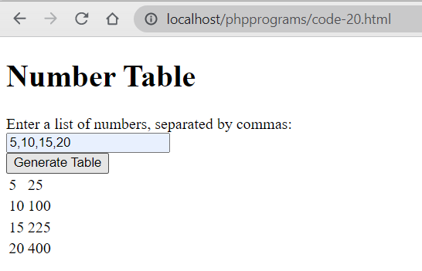

**EXPERIMENT-21**

**AIM:** Access web service using Ajax and handle using JSON.

**CODE:**

**JS CODE**

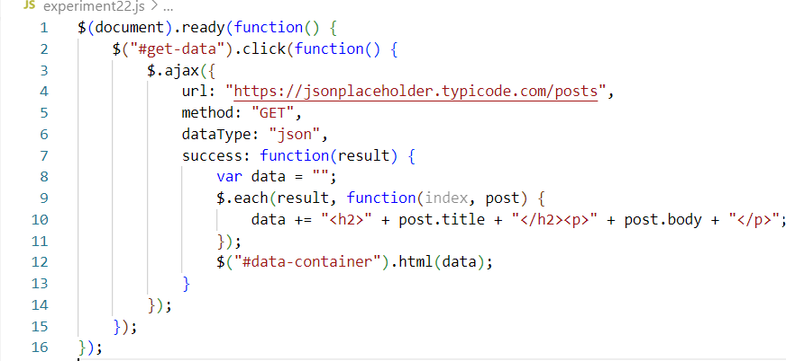

**PHP CODE:**

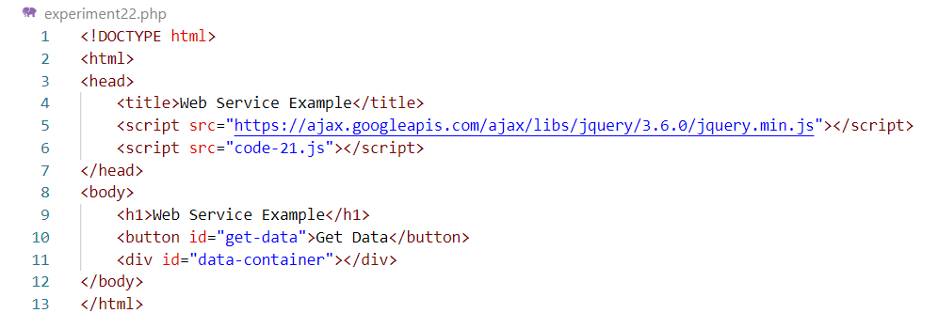

**\**

**OUTPUT:**

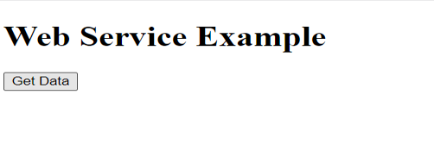

**EXPERIMENT-22**

**AIM:** Create a responsive website using bootstap

**CODE:**

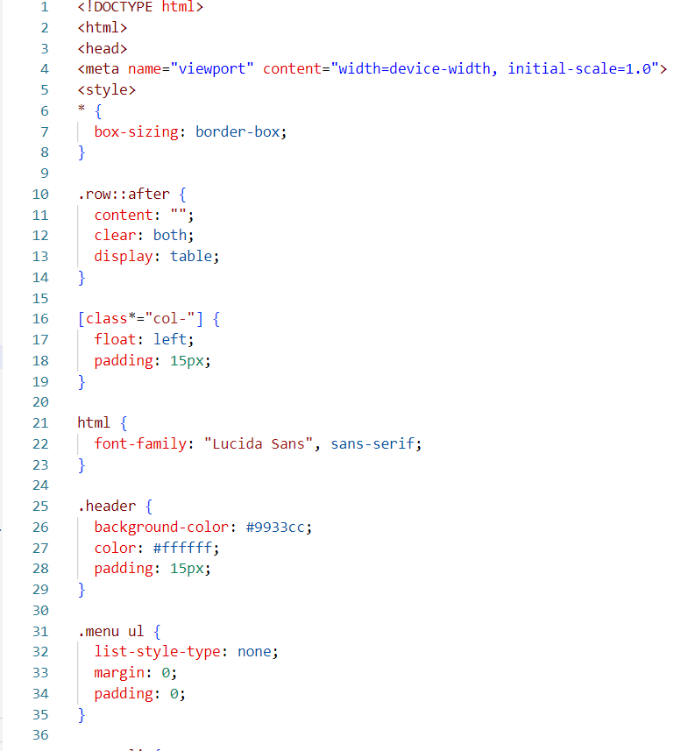

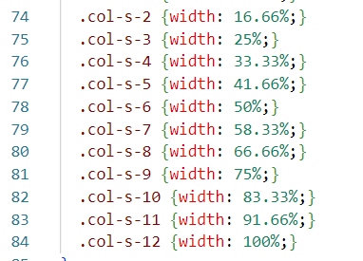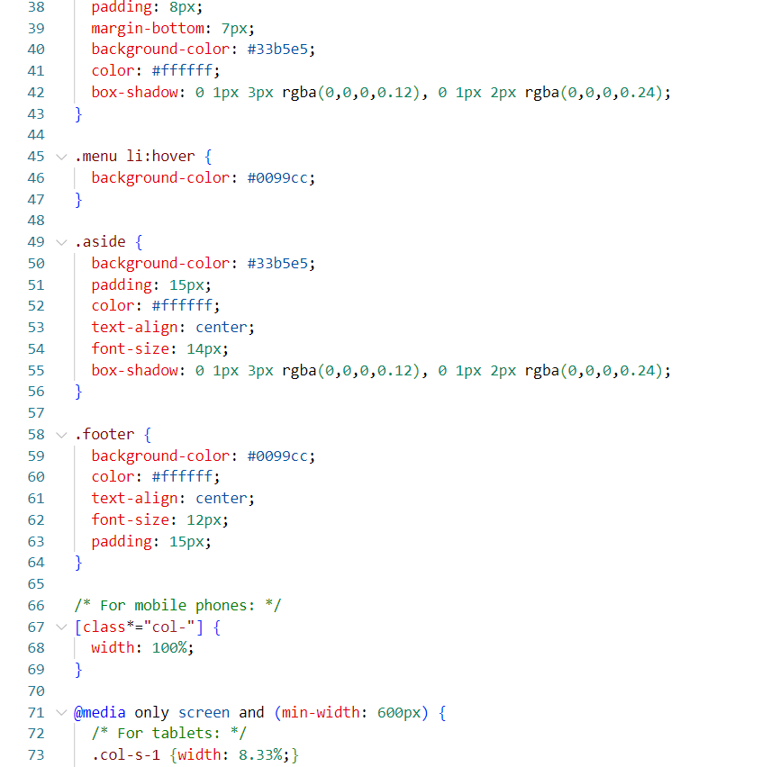

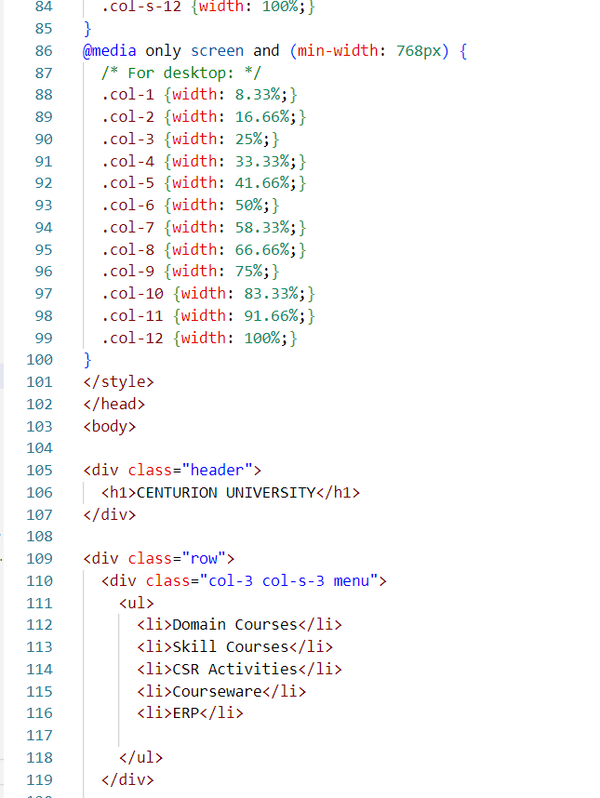

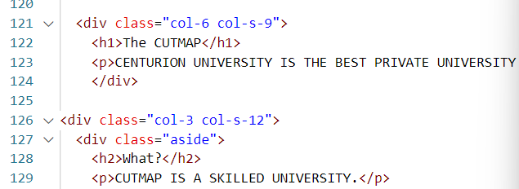

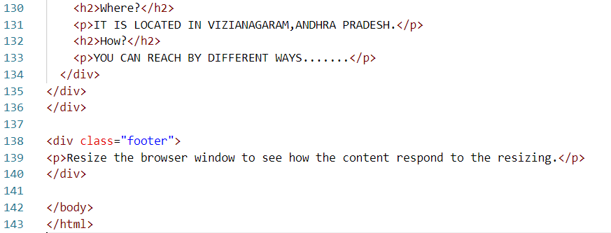

**OUTPUT:**

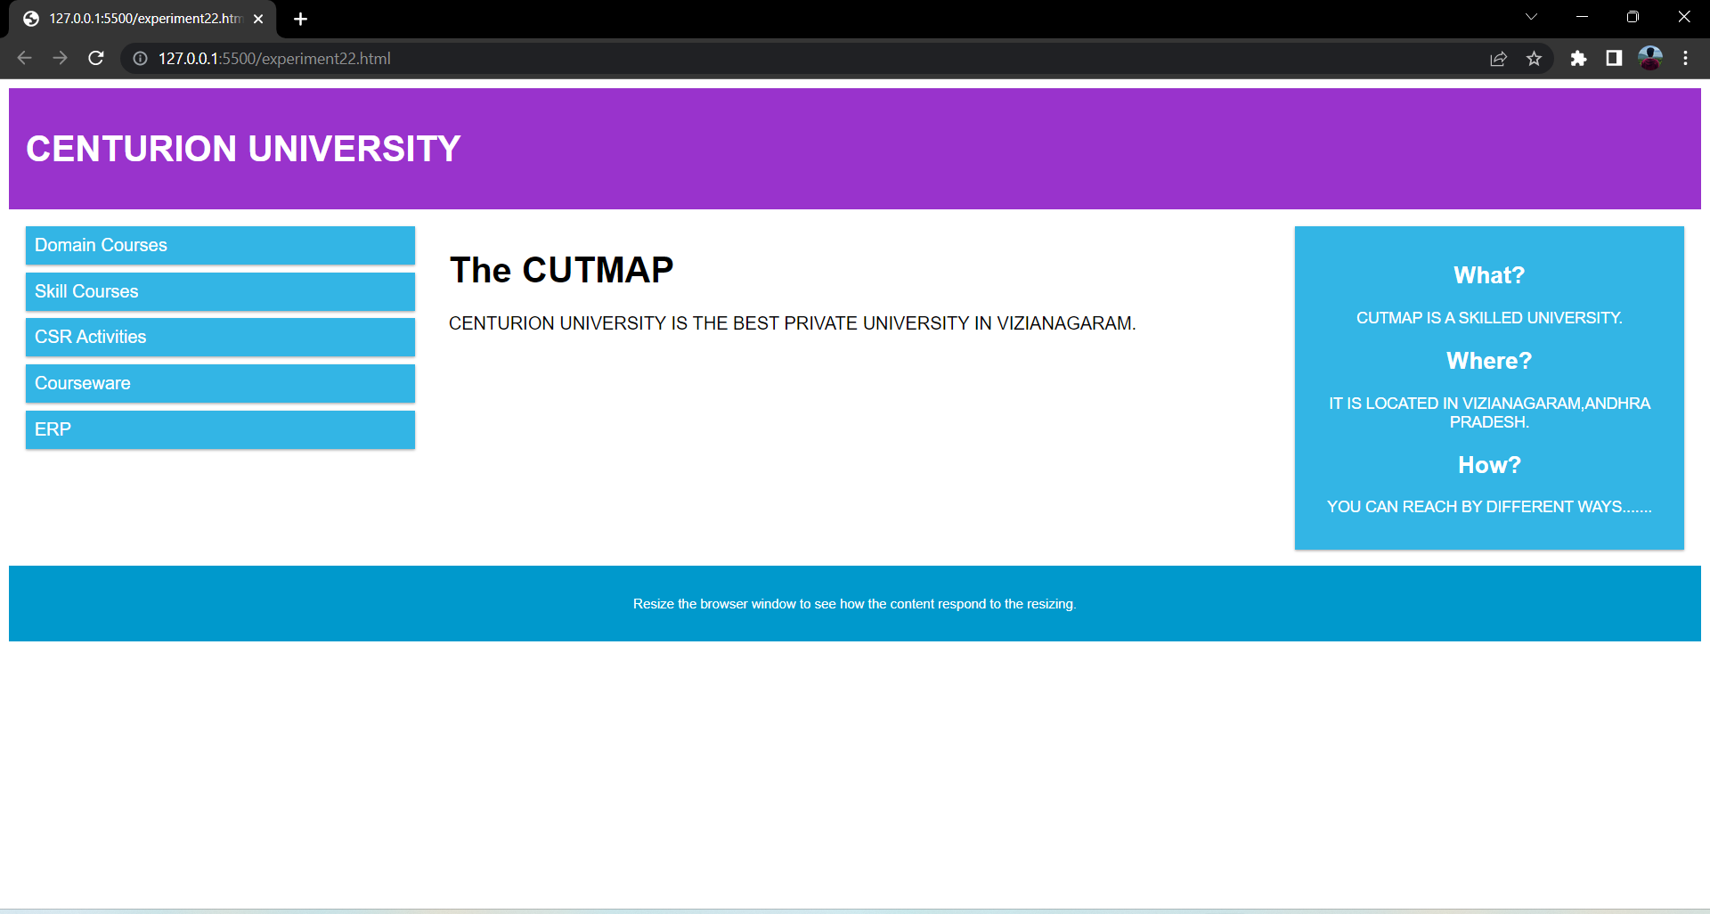

**EXPERIMENT-23**

**AIM:** Develop student registration web application using PHP.

**CODE:**

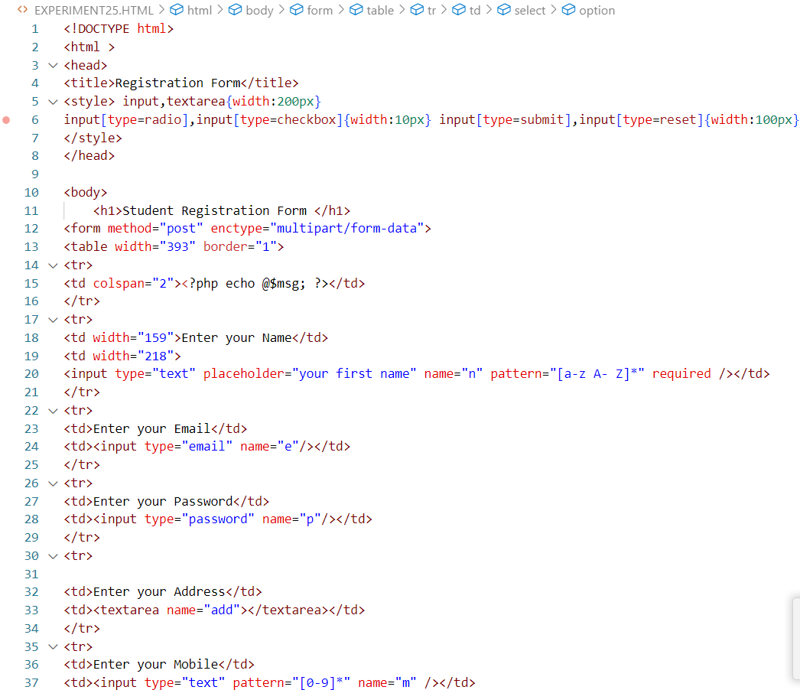

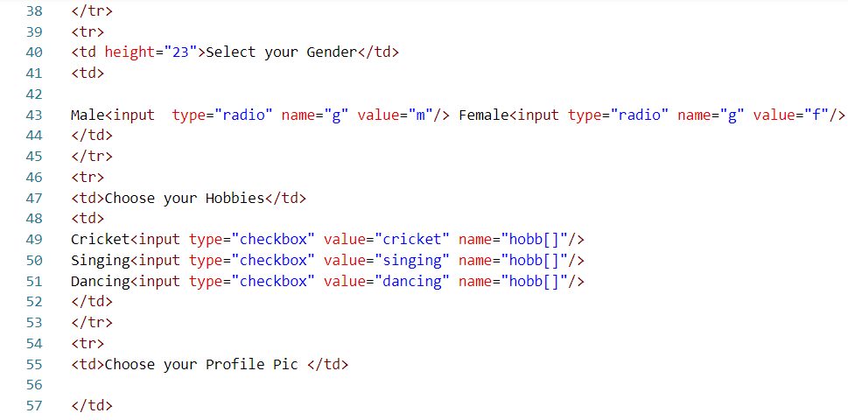

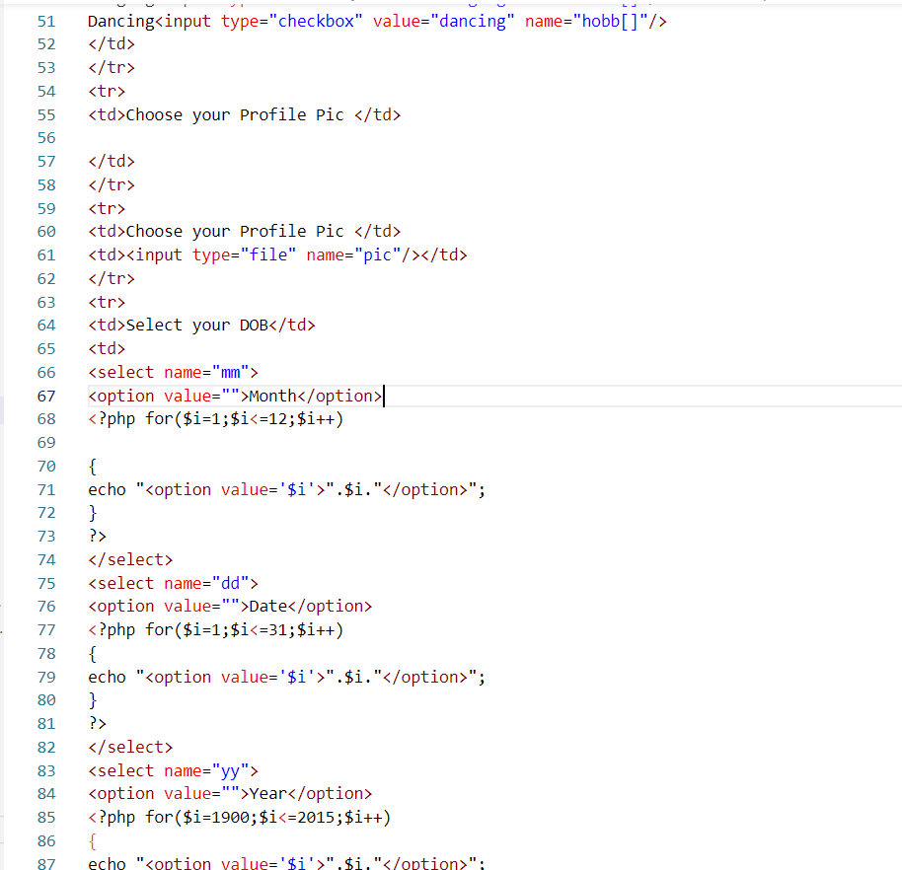

**OUTPUT:**

